FMB tools
Build, check and run TUFLOW models in QGIS
User Guide and Technical Reference
Every page of the plugin explained, with the model checks, stability flags, model-health parameters, suggestion rules and the references they are based on.
Plugin version 0.11.0 | TUFLOW Classic / HPC manual 2026.3 | QGIS 3.22 or later
Author: Rahul Pandey | October 2026
FMB tools is an independent open-source project (GPL-2.0-or-later). It is not developed, endorsed or supported by BMT or the TUFLOW team, or by Jacobs (Flood Modeller). TUFLOW is a trademark of BMT. A TUFLOW licence (or the free demo mode) is needed to run simulations.
Contents

(If the contents list is empty, right-click it in Word and choose Update Field.)

1 Introduction
FMB tools builds, checks and runs TUFLOW Classic and HPC models from inside QGIS. Instead of writing control files in a text editor, you pick commands from guided lists, enter values with the right kind of input (radio buttons, number boxes with units, file and layer pickers) and see the exact file text update as you work. The plugin also creates the TUFLOW GIS layers, imports Jacobs Flood Modeller models, checks the model before it runs, reads the run logs and results afterwards, and suggests values that improve the model.

1.1 What the plugin does
- Set-up: standard TUFLOW folder structure, new model wizard (solver, cell size, units, GIS format, times, outputs), 2D domain drawn on the map.
- Import: a Flood Modeller event file (.ief), 1D network (.dat) or 2D model (.xml) becomes a TUFLOW model - 1D converted to ESTRY or kept in Flood Modeller as a linked model.
- GIS layers: TUFLOW empty layers (2d_code, 2d_mat, 2d_bc, 1d_nwk ...) with the attribute structure TUFLOW expects, default values and editable dropdowns.
- Control files: an editor for every TUFLOW control file with the full command index of the TUFLOW 2026.3 manual (696 commands) and brief explanations.
- Checks: pre-run quality checks (required commands, files, layers, timestep, materials, BC database, events ...).
- Run: batch files for scenarios and events, run from QGIS with a colour-coded console.
- After the run: log viewer, stability flags (mass error, HPC timestep, control numbers), suggested values, and results loaded with flood-mapping symbology.

1.2 Requirements and installation
Item | Requirement
QGIS | 3.22 or later (Qt5 or Qt6 / QGIS 4 ready).
Python packages | GDAL / OGR (shipped with QGIS) - used to write GeoPackages and Shapefiles.
TUFLOW | Only needed to run simulations, write TUFLOW's own empty files and check files. A licence or the free demo mode (up to 100,000 cells).
Install | QGIS > Plugins > Manage and Install Plugins > Install from ZIP > select fmb_tools.zip. Open it from Plugins > FMB tools or the toolbar button.

1.3 The window
The plugin opens as its own window with a taskbar button, so it can sit next to QGIS or on a second screen. Minimising it does not close it; the menu or toolbar button brings it back. Its size and position are remembered.
Part | What it shows / does
Header | Model name, chips for solver / hardware, cell size and events, unsaved files, the credit line, the search box (Ctrl+K) and the Run QC, Test run, Run and Save buttons.
Sidebar | The workflow steps in order (Home, Build, Run, Check, Results, Help). Each step shows a status circle: green = done, amber = needs attention, red = error, grey = to do. Ctrl+B switches between full width, a compact vertical rail (circle + short label) and icons only. On screens narrower than 1800 px the rail is used automatically.
Page header | The page title and a one-line description.
Status bar | Messages about the last action (what was written, saved or added).
Bottom bar | New Project, Reset All, Close Project. Unsaved edits are always offered for saving first.

Keyboard shortcuts
Keys | Action
Ctrl+K | Command palette: jump to any page, run an action or find any TUFLOW command by name or explanation.
Ctrl+S | Save all control files.
F5 | Run the model checks (QC).
Ctrl+B | Cycle the sidebar: full / rail / icons.

2 Typical workflow
The sidebar follows the order in which a TUFLOW model is built. The Dashboard always shows the next step and jumps straight to the command that finishes it.
- Project & domain - choose the root folder and model name, the solver (HPC / Classic) and cell size, draw the 2D domain on the map. The 2d_loc line is written and added to the map as soon as you draw. Or import a Flood Modeller model.
- GIS layers - create the empty layers you need (active area 2d_code, materials 2d_mat, boundaries 2d_bc, 1D network ...) and draw in them in QGIS.
- TCF, TGC, TBC, ECF, TEF - point the control files at the layers, the DEM and the databases; set times and outputs.
- Data - fill the BC database (bc_dbase.csv), materials (materials.csv) and time-series CSV files.
- Checks - run QC and fix every error; then run TUFLOW in test mode (-t) and look at its check files.
- Run - write the batch file and run the simulations.
- Logs, Stability, Outputs - review warnings, mass error and the HPC timestep, apply the suggestions, load the results.
Tip: Every control file path is written relative to the control file, Windows style (..\model\gis\...), with aligned == and CRLF line endings, exactly as TUFLOW expects. Lines the plugin does not recognise are kept unchanged.

3 Page reference
This chapter explains every page of the plugin in the order of the sidebar.

3.1 Dashboard (Home)
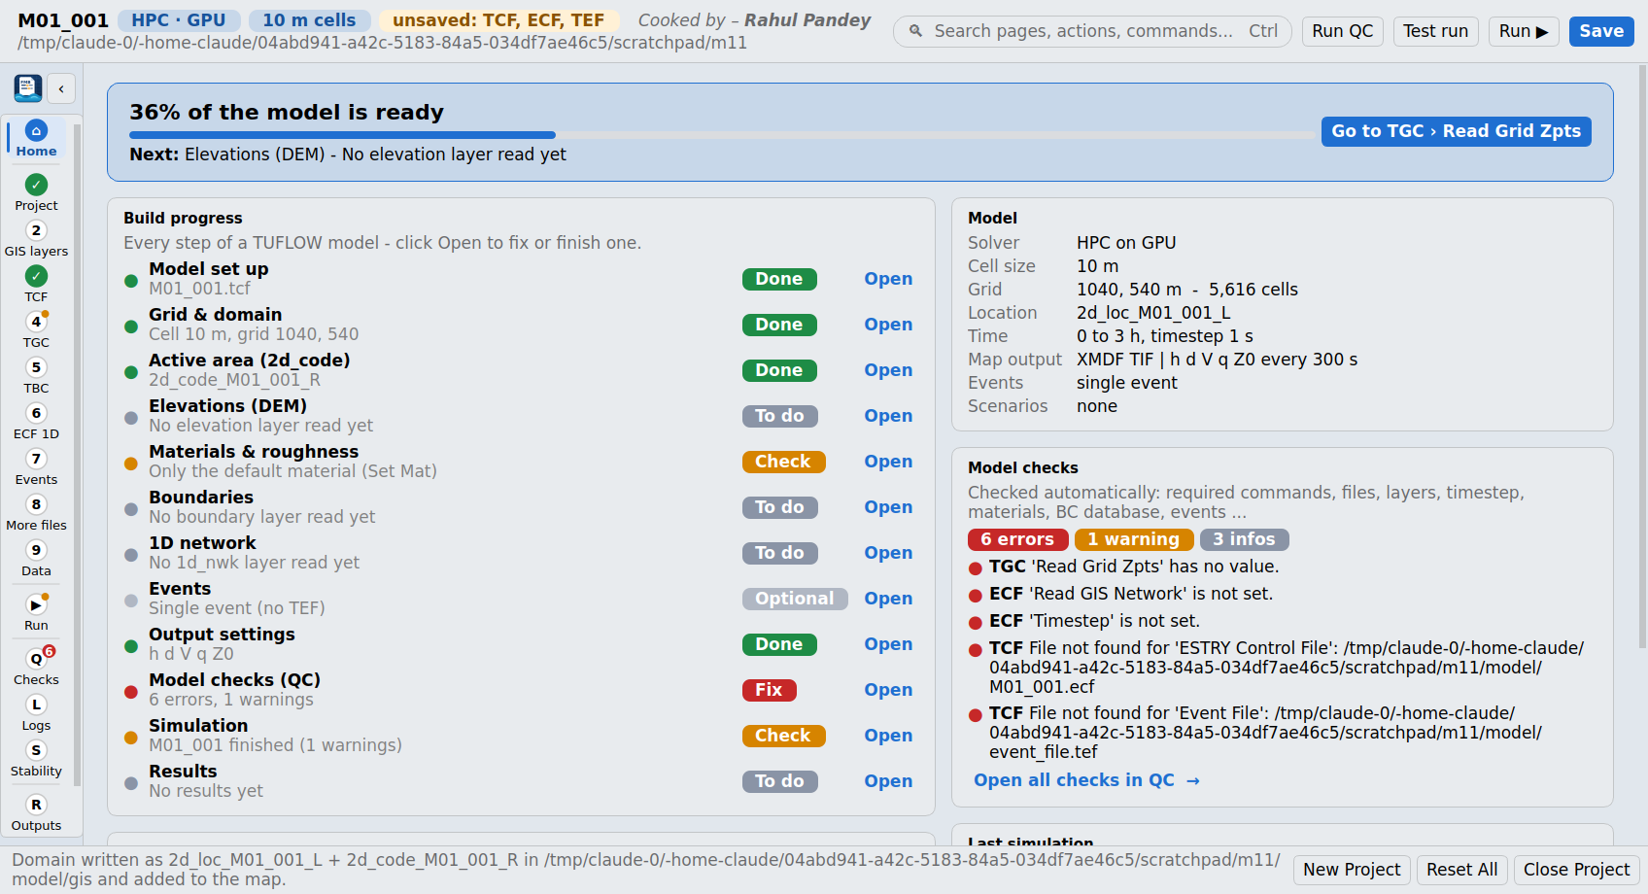
Figure 1 - Dashboard of an open model
With no model open the Dashboard welcomes you with New model, Open existing .tcf, Import Flood Modeller model and Create TUFLOW folder structure, plus the recent models. With a model open it shows how ready the model is and what to do next.

Readiness and the next step
% of the model is ready = the share of the required build steps (table below) whose state is Done. Optional steps (1D network, events) do not count. The Next line picks the first step that is broken (error), then the first unfinished build step, and only then checks, run and results - because most QC errors come from an unfinished build step. Go to ... opens the page and selects the exact command (for example TGC > Read Grid Zpts).

Build progress - how each step is judged
Step | Done when ... | Other states
Model set up | The TCF has been saved to disk. | Check = control files not saved yet.
Grid & domain | TGC has Cell Size, Grid Size and a location (Read GIS Location or Origin) - or a Quadtree file. | To do = something missing (listed); Error = the 2d_loc layer is not found.
Active area (2d_code) | Every Read GIS / Grid Code layer exists. | To do = none read; Error = a layer is missing.
Elevations (DEM) | Every Read Grid / GIS / TIN Zpts input exists. | To do / Error as above.
Materials & roughness | A 2d_mat layer is read and the materials file exists. | Check = only Set Mat (one material) or no Read Materials File; Error = materials file not found.
Boundaries | A 2d_bc / 2d_sa / 2d_rf layer (or Global Rainfall BC) is read and the BC database exists. | Error = no BC Database command or file not found.
1D network (optional) | The ECF reads its 1d_nwk layers and they exist. | Optional when there is no ECF.
Events (optional) | The TEF defines events. | Optional = single event.
Output settings | Output Folder and Map Output Data Types are set. | To do otherwise.
Model checks (QC) | No QC errors or warnings. | Error / Check with the counts.
Simulation | The latest .tlf log says the run finished without warnings. | Check = finished with warnings; Error = unstable / stopped / interrupted; To do = not run.
Results | Result grids (_Max), XMDF or NetCDF files exist in the results folder. | To do = no results yet.

Other cards
Card | Content
Model | Solver and hardware, cell size, grid size and cell count, location, run time and timestep, map output format / types / interval, events and scenarios.
Model checks | Live counts of QC errors, warnings and notes with the first five problems; link to the Checks page.
Last simulation | Status of the newest log, Test run (-t) and Run buttons, links to Logs, Stability and Results.
Input layers | Every GIS layer and grid the control files read, found or missing, and Load model inputs to map (grouped by control file, TUFLOW styles and editable dropdowns applied).
Control files | Each control file with its state (saved / modified / not saved) and Open link.
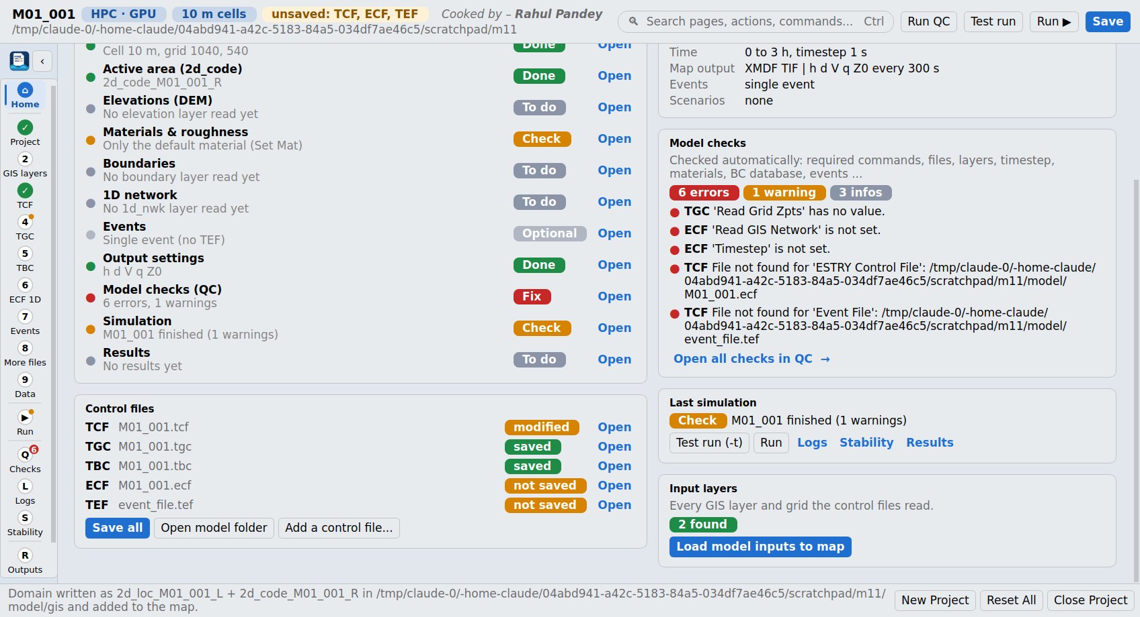
Figure 2 - Dashboard, lower cards

3.2 Project & domain
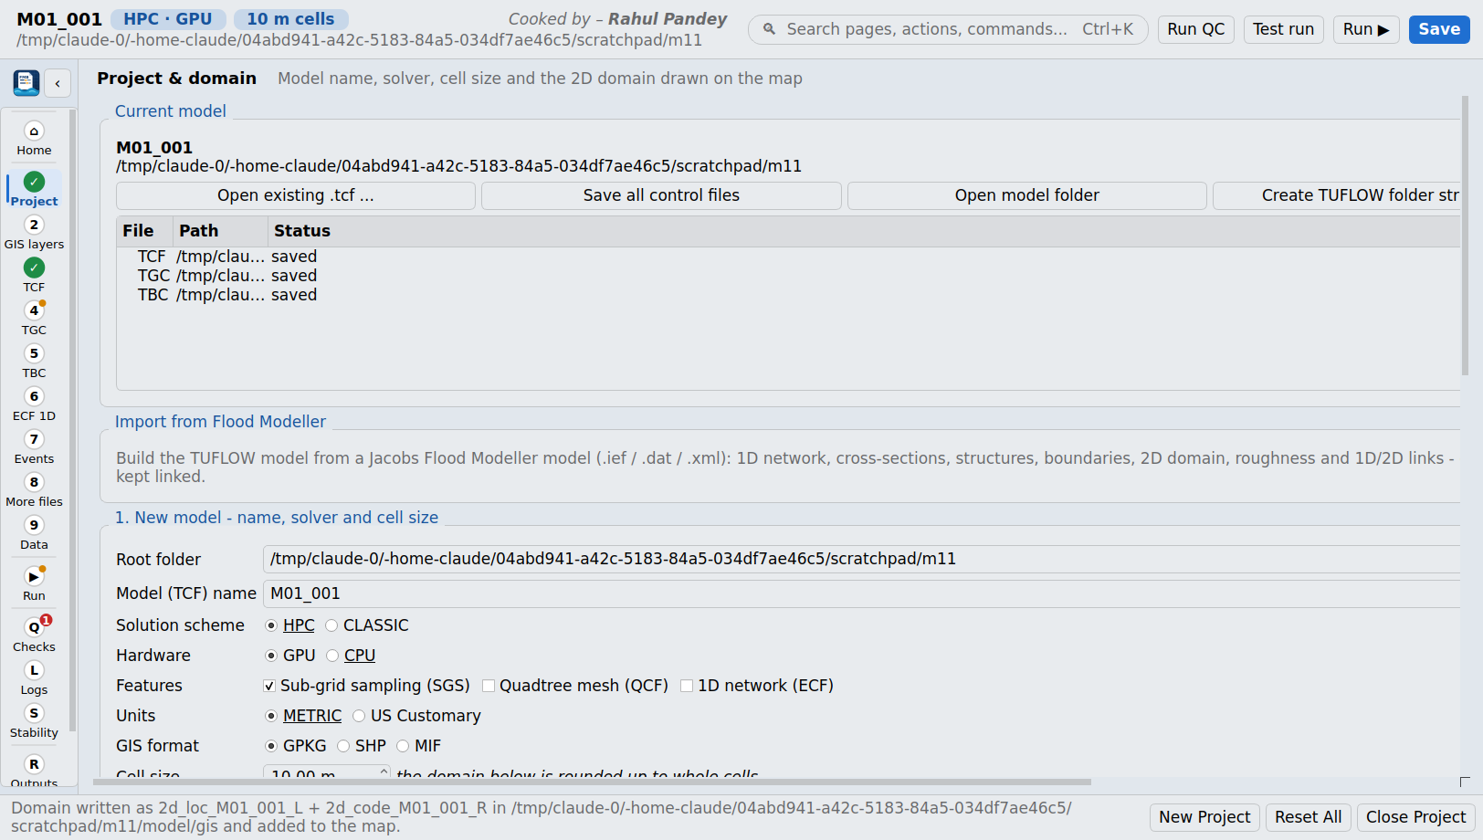
Figure 3 - Project & domain page

Current model
Shows the open model and its control files. Buttons: Open existing .tcf (every referenced control file is found and opened in its page), Save all control files, Open model folder, Create TUFLOW folder structure and Reopen last model. Double-click a file to open its page.

Import from Flood Modeller
Opens the Flood Modeller import window - see section 3.3.

1. New model - name, solver and cell size
Field | Meaning | TUFLOW command written
Root folder | Folder that will hold bc_dbase, check, model, results and runs. | -
Model (TCF) name | File name of the TCF; may contain ~s1~ / ~e1~ tokens for scenarios and events. | -
Solution scheme | HPC (current solver, adaptive timestep, GPU or CPU) or CLASSIC (fixed timestep, CPU). | Solution Scheme
Hardware | GPU or CPU (HPC only). | Hardware
Features | Sub-grid sampling (SGS), Quadtree mesh (QCF), 1D network (ECF). | SGS, Quadtree Control File, ESTRY Control File
Units | METRIC or US Customary. | Units
GIS format | GPKG (one GeoPackage), SHP or MIF. | GIS Format, Spatial Database
Cell size | 2D cell size; the domain is rounded up to whole cells. | Cell Size

2. 2D domain - draw it on the map
Tool | How it works
Draw area (polygon) | Click around the area to model and double-click to finish. The smallest grid that covers it is fitted - rotated if that needs fewer cells (Rotate to fit). The polygon can also become the 2d_code active area.
Rotated rectangle (3 clicks) | Click the origin, a point along the X axis and the far side.
Rectangle (2 clicks) | Two opposite corners, not rotated.
Map view | Uses the current map extent.
Fit to layer | Fits the grid to a layer (or its selected features).
Fields | Origin X/Y, rotation and grid size can also be typed or pasted (paste 'X, Y' into the first box fills both).
Options: margin around the drawing, snap the origin to whole cells, show the cells on the map, use the drawn area as 2d_code, and write the 2d_loc line. The summary under the tools shows origin, rotation, size, the number of cells (amber above 5 million, red above 20 million) and the TGC lines that will be written.
Tip: As soon as the domain is drawn, fitted or edited, the 2d_loc line (Read GIS Location: first vertex = grid origin, direction = grid X axis) and, if chosen, the drawn area as 2d_code are written and added to the map in the group TUFLOW inputs / 2D domain (TGC). Without a root folder they go to a temporary folder until you create the model. With a model open, the TGC is pointed at them, the Grid Size is updated and any Origin / Orientation lines are switched off.

3. Inputs and 4. Time & output
Optional existing layers (DEM, 2d_code, 2d_loc, 2d_mat, 2d_bc, projection layer), start and end time (hours), timestep (s; for Classic it is suggested as 1/4 of the cell size), map output format and data types, map and time-series output intervals, inflow type (boundary inflows or direct rainfall) and event names. Create new model writes the folders, TCF / TGC / TBC (and ECF / QCF / TEF when chosen), bc_dbase.csv and materials.csv.
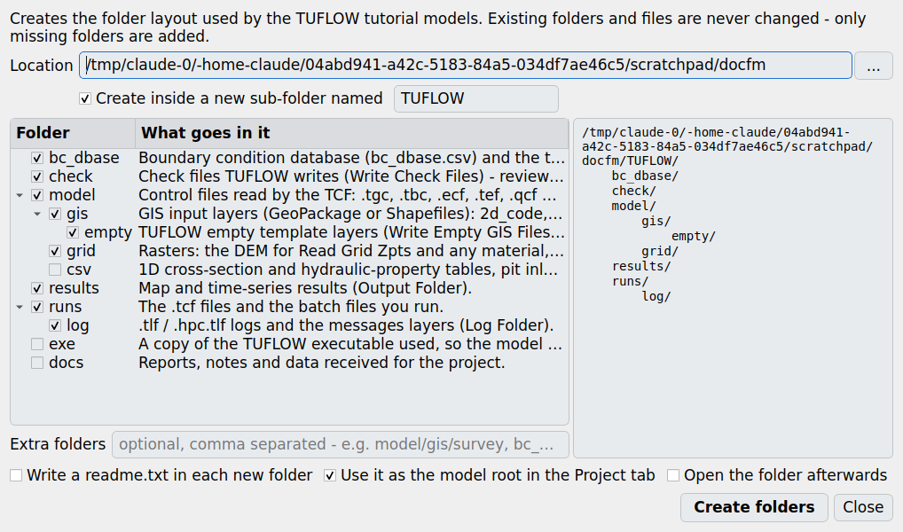
Figure 4 - Create TUFLOW folder structure
Create TUFLOW folder structure makes the folder layout used by the TUFLOW tutorial models (bc_dbase, check, model/gis/empty, model/grid, results, runs/log; optional model/csv, exe, docs and your own folders), with a preview and optional readme notes. Existing folders and files are never changed.

3.3 Flood Modeller import
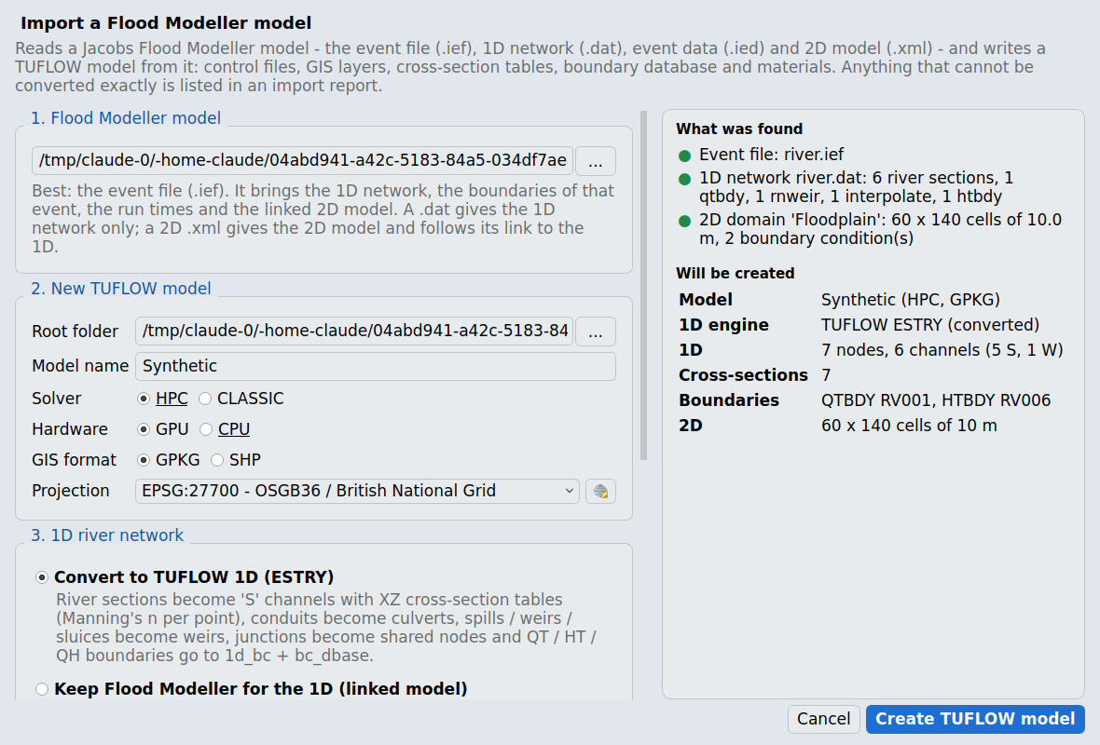
Figure 5 - Import a Flood Modeller model
The import reads a Jacobs Flood Modeller model and writes a complete TUFLOW model. Pick the event file (.ief) for the best result: it leads to the 1D network (.dat), the event data (.ied) for that event, the run times and the linked 2D model (.xml). A .dat gives the 1D network only; a 2D .xml gives the 2D model and follows its link to the 1D.

Options
Option | Effect
Root folder / Model name | Where the TUFLOW model is written (default TUFLOW_<name> next to the Flood Modeller files).
Solver / Hardware / GIS format / Projection | As for a new model. The projection is taken from the Flood Modeller shapefiles (.prj) when there are any.
Convert to TUFLOW 1D (ESTRY) | TUFLOW solves the river too (see the conversion table).
Keep Flood Modeller for the 1D (linked) | Flood Modeller solves the river and TUFLOW the 2D: X1D node layer, HX / CN links, and a copy of the .ief (<name>_TUFLOW.ief) whose 2DFile points at the new TCF. The TUFLOW start / end time and timestep are commented out because Flood Modeller sets them in a linked run.
Build a 2D domain | Uses the .xml grid when there is one, otherwise a grid around the river with the margin given.
Cell size, DTM | Override the Flood Modeller cell size or topography.
Link 1D and 2D along both banks | When there is no Flood Modeller link file: HX lines through the section ends (or the LEFT / RIGHT bank markers) and a CN line from each node to each bank.
Copy the DTM grids | Copies the grids into model\grid so the model is self-contained.
SGS | Off by default to keep the Flood Modeller cell-centre topography.

What is converted
Flood Modeller | TUFLOW (ESTRY mode) | Notes
RIVER SECTION | 1d_nwk 'S' channel to the next unit; XZ cross-section CSV (X, Z, N) in model\csv\xs; 1d_xs line | Length = distance to next; Manning's n per point (Flags N, n_nF_Cd = 1 as factor). Line from the surveyed easting / northing, or drawn across the flow.
INTERPOLATE / REPLICATE | Node with a derived section | Interpolate: upstream section shifted to the interpolated bed level; replicate: previous section lowered by the bed drop.
CONDUIT CIRCULAR / RECTANGULAR | 'C' / 'R' culvert | Diameter or width / height, inverts, n; entry 0.5, exit 1.0, contraction 0.6 / 0.9. Other shapes approximated as a box (flagged).
SPILL, FLOODPLAIN | 'W' weir at the lowest crest | Width = profile length; flagged when the crest varies.
RNWEIR, WEIR, CRUMP, FLAT-V, SCWEIR, NOTWEIR, GATED WEIR | 'W' weir (breadth, crest) | Coefficient left at the TUFLOW default - check.
SLUICE | 'W' weir at the sill (gate open) | Use an 'SG' channel if the gate operates.
ORIFICE | 5 m 'C' or 'R' culvert | Flapped -> 'U' flag.
BRIDGE | 10 m 'S' channel through the bridge opening | Add the deck ('BB' channel or 2d_lfcsh) if it can surcharge.
JUNCTION, BERNOULLI, LOSS, CULVERT inlet/outlet, BLOCKAGE | Shared node | Head loss not modelled - add Form_Loss if it matters.
QTBDY / HTBDY / QHBDY | 1d_bc QT / HT / HQ + bc_dbase + CSV | Times converted to hours; .ied event data overrides the .dat.
Hydrology units (FEH, ReFH, FSR ...) | QT placeholder with an empty CSV | Export the hydrograph from Flood Modeller and paste it in.
RESERVOIR, POND, LATERAL, pumps, syphons ... | Not converted (listed) | Use nodal storage (NA tables), QT boundaries or the suggested ESTRY channel type.
.xml computational area | 2d_loc, Grid Size, Cell Size, rotation | Rotation used as degrees anticlockwise - check.
.xml active / deactive area | 2d_code Code 1 / 0
.xml topography | Read Grid Zpts (copied to model\grid) | Z-line shapefiles listed for redrawing as 2d_zsh.
.xml roughness (global / file) | materials.csv + Set Mat / 2d_mat | The Manning's n field of a roughness shapefile is detected automatically.
.xml boundaries | waterelevation -> HT, totalflow -> QT, verticalflow -> 2d_sa / ST, freeflow -> HQ (slope 0.001) | Time-varying, fixed, CSV and IED values are written to bc_dbase.
.xml time, run data, output | Start / End Time, Timestep, Cell Wet/Dry Depth, Set IWL, Map Output Data Types / Interval
.xml link1d shapefile | 2d_bc HX lines + CN lines to nodes within 3 cells (min. 100 m)

Node locations
Node coordinates come from the section points (BED marker or lowest point), then the .gxy file, then GISINFO (0,0 is treated as missing). Nodes between two located nodes are placed along the line by distance; nodes with no coordinates at all are laid out schematically and listed in the report so you can move them onto the river.

Import report
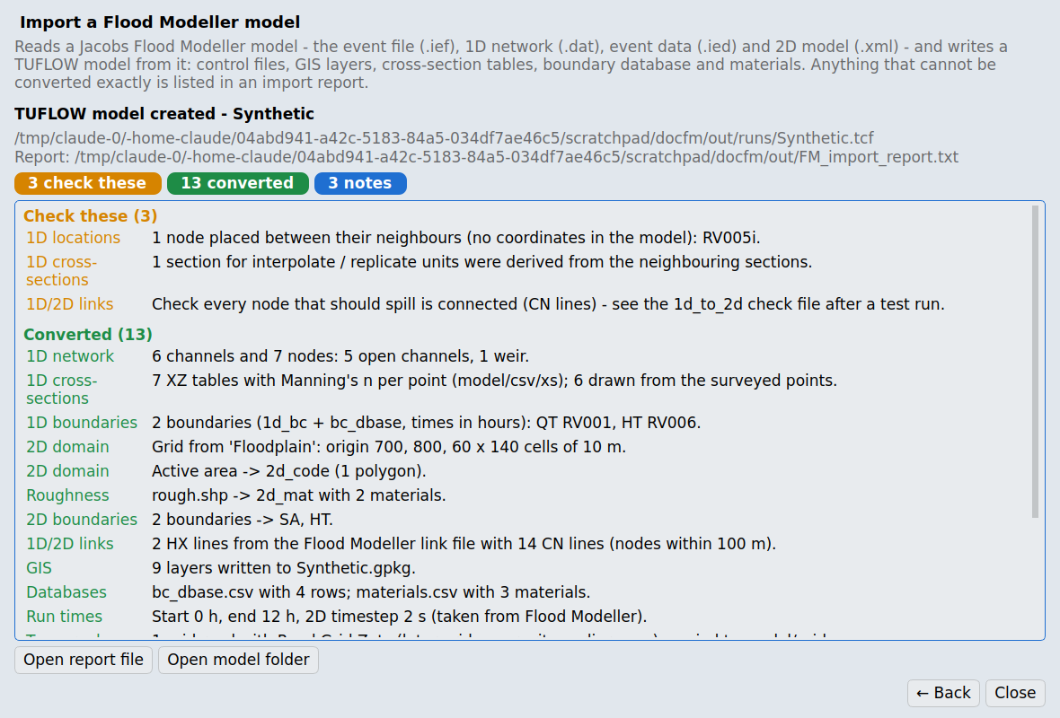
Figure 6 - The import report
The report, shown in the window and saved as FM_import_report.txt in the model root, has four groups: You need to finish these (red - the model will not run correctly until done), Check these (amber - approximations to review), Converted (green) and Notes (blue).

3.4 GIS layers (Empty layers)
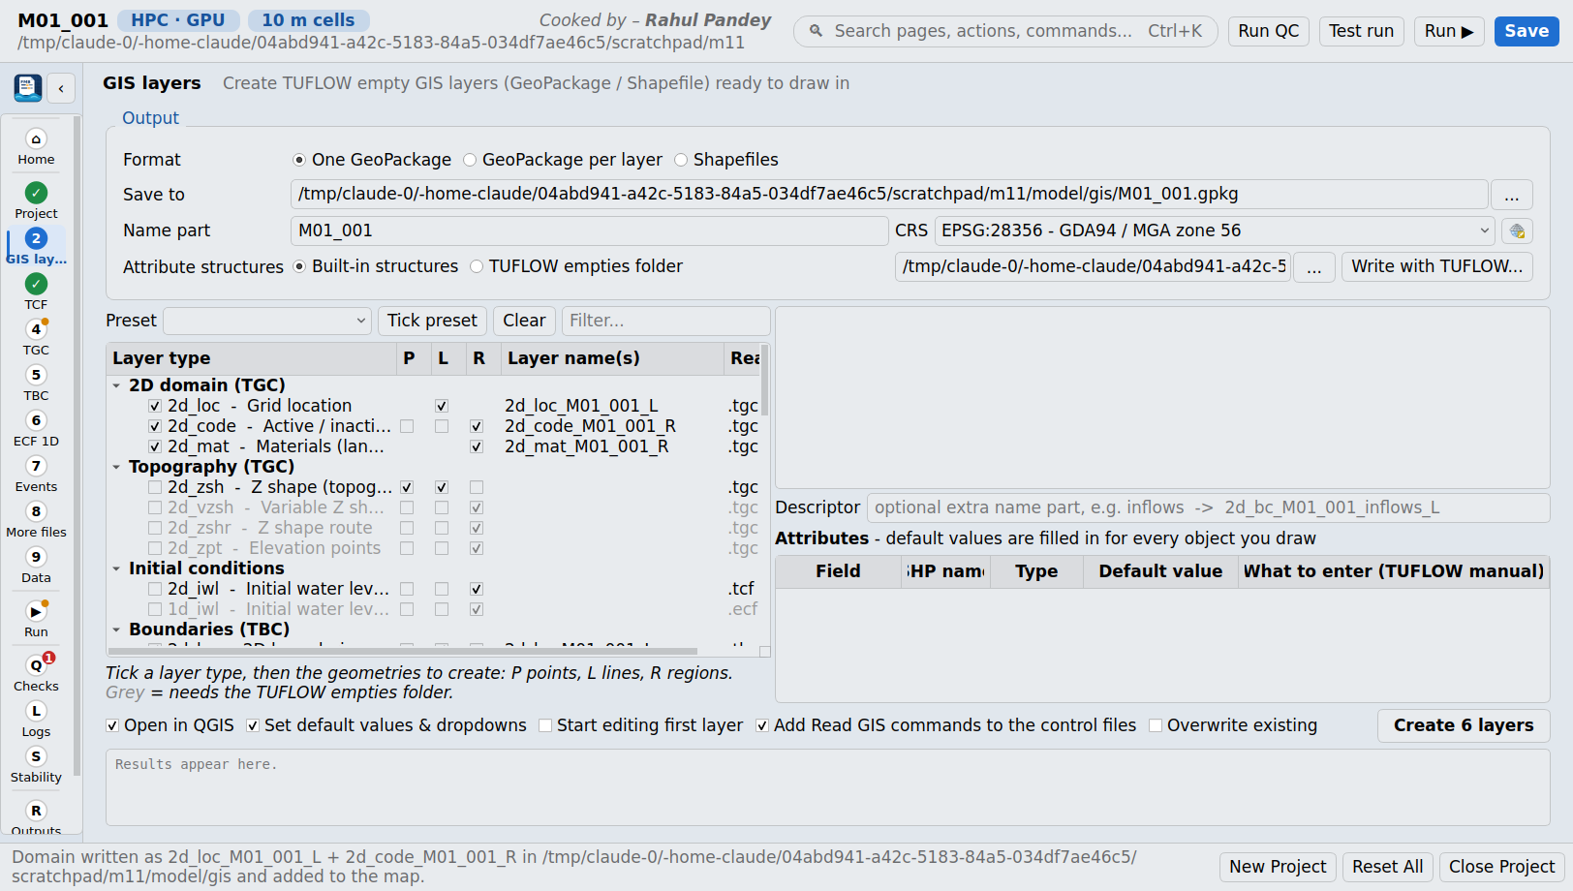
Figure 7 - GIS layers page
Creates TUFLOW empty GIS layers named <type>_<name>[_<descriptor>]_<P|L|R> with the attribute order TUFLOW expects, loads them into QGIS and adds the matching Read GIS commands to the control files.
Setting | Meaning
Format | One GeoPackage (recommended), a GeoPackage per layer, or Shapefiles (field names cut to 10 characters - shown in the SHP name column).
Save to / Name part / CRS | Target file or folder, the <name> part of the layer names and the projection (TUFLOW needs every layer in one projection).
Attribute structure | Built-in structures (cross-checked against real TUFLOW layers) or TUFLOW's own empty files (point to the folder, or Write with TUFLOW runs 'Write Empty GIS Files').
Preset | 2D base model, Topography update, Direct rainfall, Source-area inflows, 1D/2D culverts, 1D open channel, 2D bridges, Quadtree, Initial water level.
Layer list | Grouped by control file; tick P (points), L (lines), R (regions) for each type. Each layer shows what to draw.
Attributes table | Every field with its type, Shapefile name, a default value and what to enter (from the TUFLOW manual).
Options | Open in QGIS, set default values & dropdowns, start editing the first layer, add Read GIS commands, overwrite existing.

Editable dropdowns in the attribute form
Fields with usual values get an editable dropdown in the QGIS attribute form and table: pick a value (shown with its meaning) or type any other value - for example a culvert type with flags such as 'CU'. The same dropdowns are applied when layers are loaded with Load model inputs to map or by the Flood Modeller import.
Layer | Field | Suggested values
1d_nwk | Type | S, G, C, R, I, B, BB, BArch, CU, RU, W, WB, WC, WD, WO, WR, WT, WV, WW, VW, SG, SP, P, M, Q, X, PF, DF
1d_nwk | Ignore, UCS | blank, T, F
2d_bc | Type | QT, HT, HQ, ST, RF, HX, SX, CN, 2D, CD, VG, HS
2d_bc, 1d_bc, 2d_sa, 2d_rf ... | Name | Names in the model's bc_dbase.csv
2d_mat | Material | IDs in the model's materials.csv (with Manning's n)
2d_code | Code | 1 active, 0 inactive
2d_po | Type | H_, d_, V_, VX, VY, E_, Q_
2d_zsh | Shape_Options | ADD, MAX, RIDGE, RAISE, MIN, GULLY, LOWER, TIN, MERGE, NO MERGE
1d_xs / 1d_tab | Type | XZ, HW, CS, NA, BG, LC, DD
1d_bc | Type | QT, HT, HQ, QH
2d_sa_tr / 2d_sa_po | Trigger / PO type | Q_, H_

3.5 Control file pages (TCF, TGC, TBC, ECF 1D, Events)
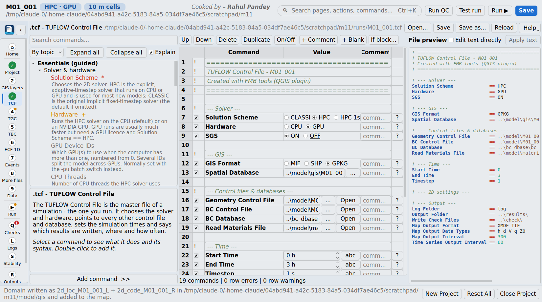
Figure 8 - TCF editor
Each control file has the same editor.
Part | What it does
Command browser (left) | Essentials (guided): the commands most models need, marked * required and + recommended, each with a brief plain-language explanation (untick Explain for a compact list). By topic / A-Z: every command of the TUFLOW 2026.3 manual appendices A-K, with search. Double-click (or Add command) to add one.
Info panel | Syntax, default, tips and a link to the manual page for the selected command.
Command table (centre) | One row per line of the file: on/off tick, command (modifier dropdowns such as Read GIS Z Shape RIDGE), value editor, comment, help. Toolbar: Up, Down, Delete, Duplicate, On/Off (comment out), + Comment, + Blank, If block (wrap in If Scenario / If Event).
Value editors | Radio buttons for short option sets, dropdowns for longer lists, number boxes with units and a 'not set' state, X/Y pair boxes, keyword + number choices (e.g. AUTO or a value), file / folder / QGIS layer pickers (GeoPackage >> syntax), and dropdowns filled from the model (scenarios, events, BC names, material IDs). The abc toggle keeps <<variables>> and ~s1~ tokens as text.
File preview (right) | The exact text that will be written, syntax-highlighted. Edit text directly lets you type into it; Apply text reads it back.
Status line | Counts of commands, errors and warnings per row (missing values, unknown commands, unbalanced blocks).

Required commands per file (checked by QC)
File | Required commands
TCF | Solution Scheme, Geometry Control File, BC Control File, BC Database, Start Time, End Time, Timestep, Output Folder, Map Output Format, Map Output Data Types, Map Output Interval
TGC | Grid Size (X,Y), Cell Size, Set Code, Read GIS Code, Read Grid Zpts, Set Mat
ECF | Read GIS Network, Timestep
TEF | Define Event, BC Event Source, End Define
QCF / TRFC / TSCF / ADCF / TOC | Read GIS Nesting / RF Interpolation Method / Read SWMM / AD BC Database / Define Control ... End Define
The Events page adds an event generator that writes one Define Event / BC Event Source / End Define block per value (e.g. ~AEP~ = 1p, 5p, 10p), optionally with a second event text such as durations.
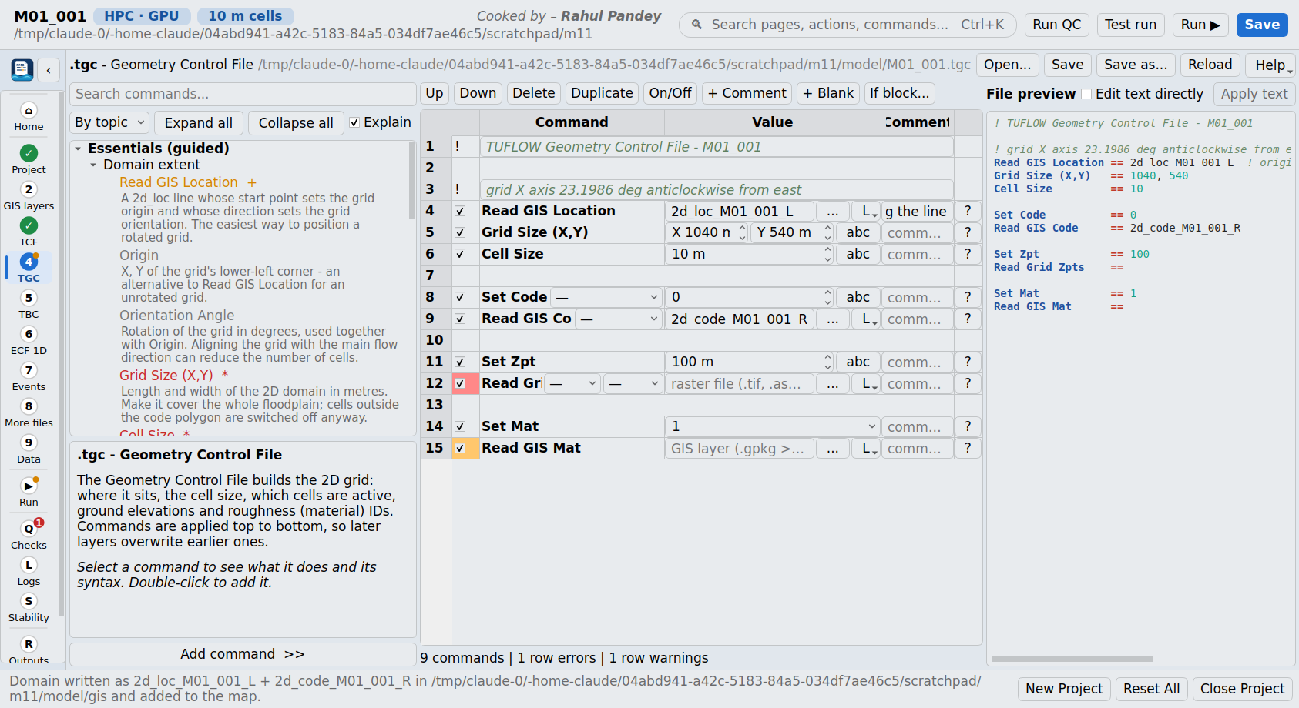
Figure 9 - TGC editor with the 2d_loc written from the drawn domain

3.6 More control files
Editors for the Quadtree (QCF), rainfall (TRFC), operational controls (TOC), external stress / wind (TESF), TUFLOW-SWMM (TSCF) and advection-dispersion (ADCF) control files. They are created and linked into the TCF (or the ECF for the TOC) on demand.

3.7 Data (Databases)
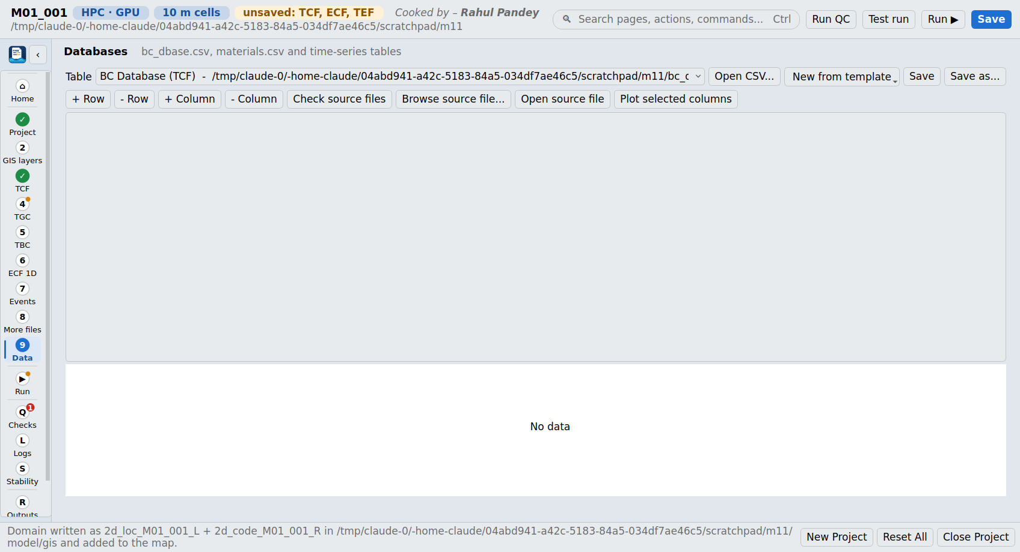
Figure 10 - Databases page
A table editor for bc_dbase.csv, materials.csv and any time-series CSV the model uses. New tables can start from templates (BC database, materials, flow hydrograph, water level, rainfall hyetograph, HQ curve, pit inlet database). Rows and columns can be added and removed, blocks of cells pasted from Excel (Ctrl+V), Check source files reports BC database sources that do not exist (with event names substituted), and Plot selected columns draws a quick chart.

3.8 Run (Batch & Run)
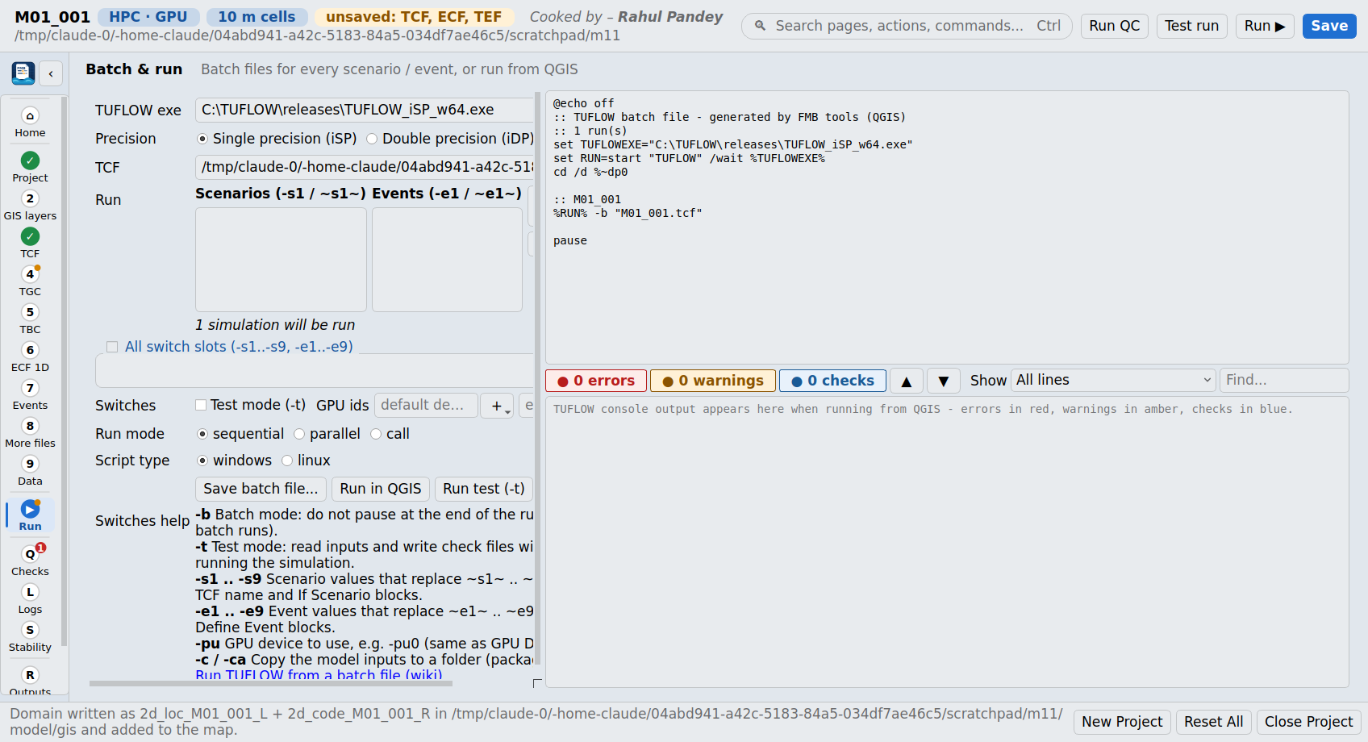
Figure 11 - Batch & Run page
Setting | Meaning
TUFLOW exe / precision | The TUFLOW executable; single (iSP) or double (iDP) precision.
Scenarios / Events | Tick the values found in the model for each slot -s1 ... -s9 and -e1 ... -e9; one simulation is written for every combination.
Switches | Test mode (-t), GPU ids (-pu0 ...), extra switches. -b (batch mode) is always used.
Run mode | Sequential (one after another), parallel (start), or call (wait for each).
Script type | Windows .bat or Linux .sh.
Actions | Save batch file, Run in QGIS (live console, colour coded: errors red, warnings amber, checks blue, finished green), Run test.
Switch | Meaning
-b | Batch mode: do not pause at the end of the run.
-t | Test mode: read the inputs and write the check files without running.
-s1 ... -s9 | Scenario values that replace ~s1~ ... ~s9~ in the TCF name and select If Scenario blocks.
-e1 ... -e9 | Event values that replace ~e1~ ... ~e9~ and select Define Event blocks.
-pu<id> | GPU device to use, e.g. -pu0.
-c / -ca | Copy the model inputs to a folder (package a model).

4 Checks (QC) - pre-run model checks
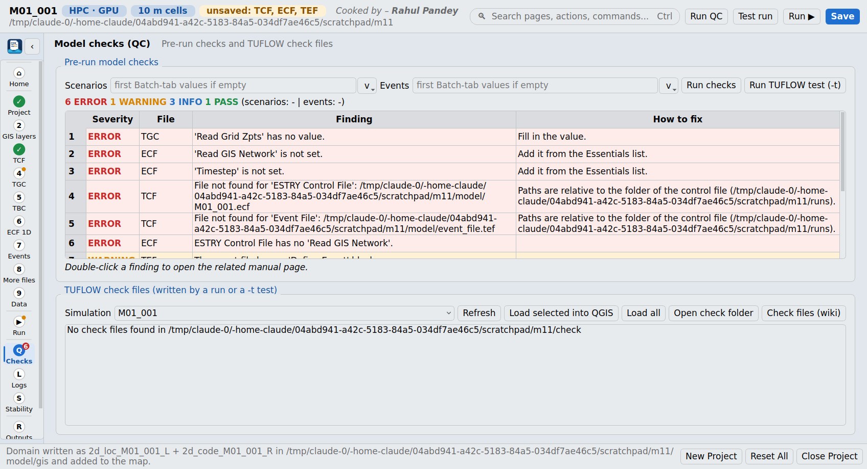
Figure 12 - Checks page
The Checks page runs the model checks without TUFLOW (F5 or Run checks), for the scenarios and events chosen in the Batch tab. Every finding has a severity, the control file, the message, how to fix it and a link to the manual page (double-click). The lower part lists TUFLOW's own check files from a test run (Run TUFLOW test (-t)) and loads them into QGIS.

4.1 Severity levels
Severity | Meaning
ERROR | TUFLOW will stop, or the model cannot be right (missing file, missing required command, impossible value).
WARNING | TUFLOW may run but the result is likely to be wrong or risky - review it.
INFO | Information or a recommendation; nothing is wrong.
PASS | A check that found everything in order.

4.2 Every check
Area | Condition | Severity | Why / fix
Required commands | A required command (section 3.5) is missing. | ERROR (Solution Scheme: WARNING; BC Database when no boundaries are read: INFO) | Add it from the Essentials list. Start / End Time and Timestep are not required when the model is linked to Flood Modeller; Grid Size / Cell Size not with Quadtree or Read Grid Location.
Required commands | A required command is present without a value. | ERROR | Fill in the value.
Blocks | If / Else If / Else / End If or Define / End Define not balanced. | ERROR | Balance the blocks (line number given).
Unknown commands | A command is not in the TUFLOW 2026.3 command index. | WARNING | Check the spelling (commands are not case sensitive).
Files | Spatial Database file not found. | ERROR | Create the GeoPackage or fix the path.
Files | A file read by a command is not found (GIS layer, grid, CSV, control file, database). | ERROR | Paths are relative to the folder of the control file. TUFLOW lets you omit GIS extensions; .shp, .mif, .gpkg, .tif, .asc, .flt, .csv are tried.
Files | A layer name is not in the Spatial Database, or a '>> layer' is not in the GeoPackage. | ERROR | Check the layer name.
Files | A path uses scenario / event / variable tokens that are not set. | INFO | Set the scenario and event names in the Batch tab so the paths can be checked.
Solver | Hardware == GPU without Solution Scheme == HPC. | ERROR | GPU needs HPC.
Solver | GPU Solver == ON (legacy pre-2017 GPU engine). | WARNING | Use Solution Scheme == HPC with Hardware == GPU.
Solver | Quadtree Control File with the Classic solver. | ERROR | Quadtree needs HPC.
Solver | SGS == ON with the Classic solver. | WARNING | SGS is an HPC feature.
Solver | Control Number Factor > 1. | WARNING | 'Overclocks' HPC - higher risk of instability. Keep at 1.0 or below.
Solver | Control Number Factor == 0. | WARNING | Fixed timestep with no stability control - testing only.
Solver | Defaults == <release> present. | INFO | Keeps old-release behaviour; remove for new models.
Flood Modeller link | Read GIS X1D / ISIS commands present. | INFO | Start / End Time and the 2D timestep come from the Flood Modeller .ief.
Time | End Time <= Start Time. | ERROR | Fix the times (hours).
Time | Timestep <= 0. | ERROR
Time | Classic: timestep / cell size > 0.5. | WARNING | Classic guidance: timestep (s) about 1/4 to 1/2 of the cell size (m).
Time | Classic: timestep / cell size < 0.1. | INFO | Runs will be slow; increase towards 1/4 if stable.
Time | Classic: ratio 0.1 - 0.5. | PASS
Time | HPC: Timestep set. | INFO | HPC is adaptive; Timestep is only the starting value - watch the control numbers after the run.
Geometry | No elevation (Zpt) command in the TGC. | ERROR | Add Read Grid Zpts with the DEM.
Geometry | No Set Code / Read GIS Code. | WARNING | Active area undefined: add Set Code == 0 then Read GIS Code.
Geometry | Set Code / Set Mat / Set Zpt after the matching Read command. | WARNING | TGC commands apply in order; the Set command would overwrite the layer.
Geometry | Cell Size <= 0. | ERROR
Geometry | Cell count of the grid bounding box. | INFO | Free / demo mode is limited to 100,000 cells.
Materials | Set / Read Mat used but no Read Materials File. | ERROR | Add Read Materials File to the TCF.
Materials | Read GIS Mat without a Set Mat default. | WARNING | Cells outside the polygons get material 0.
Materials | Manning's n outside 0.008 - 1.0. | WARNING | Usual range 0.01 - 0.5; check value and units.
Materials | Duplicate material IDs. | ERROR
Materials | Set Mat ID not in the materials file. | ERROR
Materials | Materials file read. | PASS | Number of IDs.
BC database | Empty file. | WARNING
BC database | First two columns are not Name, Source. | WARNING
BC database | A Source file does not exist (each event substituted from the TEF). | ERROR
BC database | Duplicate names. | WARNING | The last one wins.
BC database | Global Rainfall BC is not a Name in the database. | ERROR
Events | Events used but no Event File. | WARNING
Events | TEF has no Define Event block. | WARNING
Events | An event in the batch or Model Events is not defined in the TEF. | ERROR
Events | Event File is not the last command in the TCF. | INFO | The manual recommends placing it last.
Rainfall | Direct rainfall with Cell Wet/Dry Depth > 0.0002 m (default 0.002). | WARNING | The manual recommends 0.0002 m for direct rainfall.
Rainfall | Direct rainfall on HPC without SGS. | INFO | Consider SGS == ON on steep or fine terrain.
Outputs | Map Output Interval longer than the simulation. | WARNING | Only the maximums will be useful.
Outputs | Map Output Interval < 30 s. | INFO | Very large result files.
Outputs | No Write Check Files. | WARNING | You lose TUFLOW's own QA layers.
Outputs | No Read GIS PO. | INFO | Add plot output locations for flow / level time series.
1D | Classic: 1D timestep larger than the 2D timestep. | WARNING | Usually equal to or a fraction of the 2D timestep.
1D | ECF without Read GIS Network. | ERROR
All | No errors or warnings. | PASS | Run TUFLOW in test mode (-t) next.
Important: The plugin's checks look at the set-up only. TUFLOW's test run (-t) reads every input and writes check files (zpt, grd, bcc, 1d_to_2d, nwk ...) that show what TUFLOW actually built - always look at them before trusting a model. See the TUFLOW Wiki page 'TUFLOW Check Files'.

5 Logs
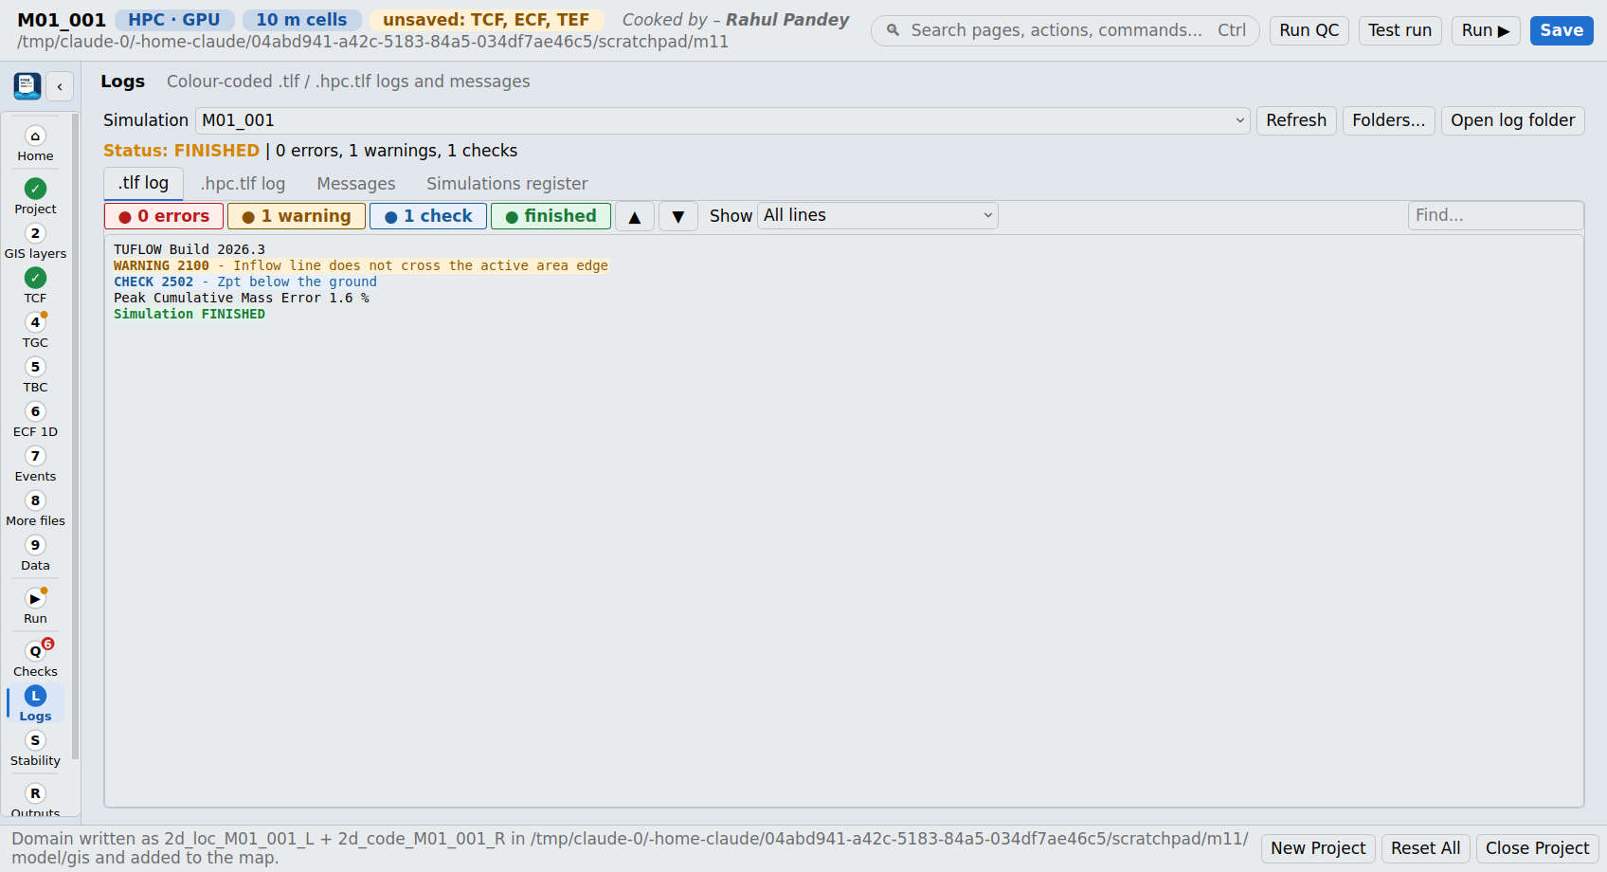
Figure 13 - Logs page
Shows the .tlf and .hpc.tlf logs of a simulation, its messages and the simulations register.
Part | What it does
.tlf / .hpc.tlf log | The log text colour coded line by line. Counts (errors, warnings, checks, finished) jump to the next line of that kind; Show limits the view to problems; Find searches.
Messages | The messages file as a table: number, type, text and X/Y. Double-click the number to open its page in the TUFLOW messages database, X/Y to zoom the map there. Load messages layer adds the GIS layer.
Simulations register | The runs listed in the register file TUFLOW keeps.

5.1 How lines are classified
Colour | Line contains ...
Red - error | ERROR / FATAL, 'error:', exception tracebacks, 'simulation unstable / interrupted / stopped / failed', NaN, 'cannot open / find / read'. Mass-error lines without an ERROR number are not counted as errors; '0 ERRORS' is good news.
Amber - warning | WARNING / 'warning:'.
Blue - check | CHECK nnnn messages.
Green - finished | 'simulation finished / completed', 'normal termination', 'finished successfully'.
Commands echoed into the log (e.g. 'Instability Water Level == ...') are not treated as messages. The run status is read from the last 80 lines: UNSTABLE, INTERRUPTED or FINISHED; otherwise ERROR (if errors were found) or RUNNING / INCOMPLETE.

6 Stability and model health
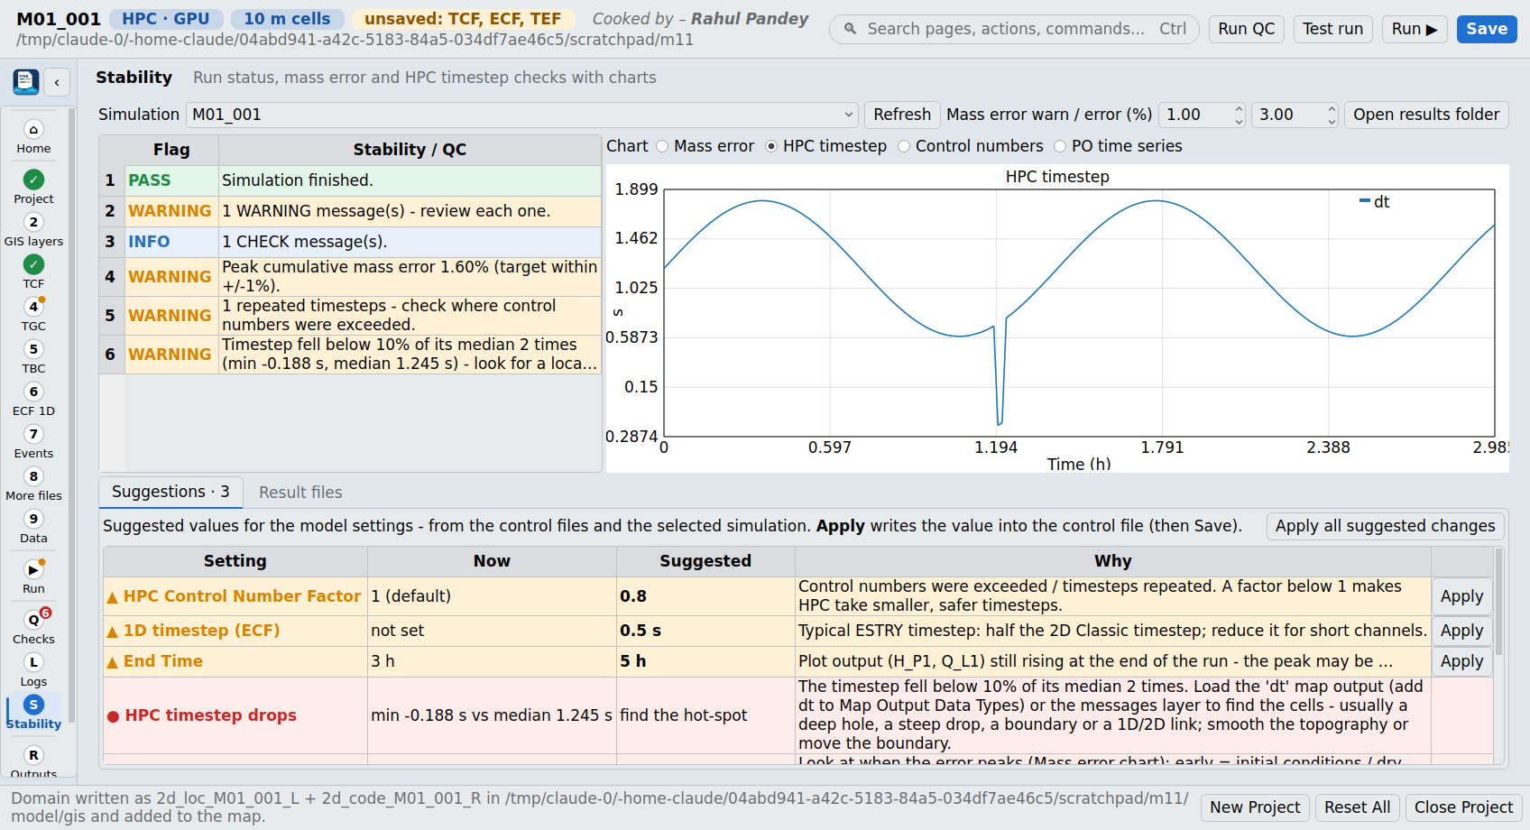
Figure 14 - Stability page with the HPC timestep chart and the Suggestions
The Stability page judges a finished (or running) simulation from four files TUFLOW writes, draws charts of them and lists suggested values for improving the model.
File | Found as | Used for
Log | <sim>.tlf and <sim>.hpc.tlf in the Log Folder | Run status, message counts, NaNs, negative depths, peak / final cumulative mass error, clock time
Mass balance | <sim>_MB.csv (or _MB2D.csv) in the results folder | Cumulative mass error over time; volume (still rising at the end?)
HPC timestep | <sim>*hpc.dt.csv in the Log Folder | Timestep and control numbers Nu, Nc, Nd and repeated timesteps over time
Plot output | <sim>*_PO.csv in results\plot\csv | Time series at the 2d_po locations; peaks still rising at the end

6.1 Stability flags
Flag | Condition | Severity
Simulation finished | The log reports a normal finish. | PASS
Went UNSTABLE | The log reports instability. | ERROR
Interrupted | The run was stopped by the user or the system. | WARNING
Stopped with errors | Status ERROR (errors and no finish line). | ERROR
ERROR messages | Any numbered ERROR in the log. | ERROR
WARNING messages | Any numbered WARNING - review each one. | WARNING
CHECK messages | Any numbered CHECK. | INFO
NaN values | NaN (not a number) in the log or HPC log - numerical instability. | ERROR
Negative depths | Classic '-d' lines (negative depths). | WARNING
Peak cumulative mass error | |peak CME| above the error limit (default 3 %). | ERROR
Peak cumulative mass error | |peak CME| above the warning limit (default 1 %). | WARNING
Peak cumulative mass error | Within the warning limit. | PASS
Repeated timesteps | HPC repeated timesteps (control numbers exceeded and the step re-done). | WARNING
Timestep drops | HPC timestep below 10 % of its median (count, minimum and median given). | WARNING
Nu / Nc / Nd exceeded | Maximum Nu > 1.0, Nc > 1.0 or Nd > 0.3. | WARNING
HPC timestep summary | No HPC problem found: minimum, median and maximum timestep. | PASS
The mass-error warning and error limits can be changed at the top of the page. The peak cumulative mass error ignores the first 5 % of the record, where small volumes make the percentage meaningless.

6.2 Model-health parameters explained

Cumulative mass error (CME)
TUFLOW tracks how much water enters, leaves and is stored in the model. The cumulative mass error is the volume that cannot be accounted for, as a percentage of the volume that has passed through the model. A well-behaved model stays within about +/-1 % for most of the run. Larger errors mean water is created or lost numerically - typically from wetting and drying, too large a timestep (Classic), boundaries in the wrong place, or the 1D/2D links. Early spikes while the model is nearly empty are normal, which is why the plugin skips the first 5 % of the record.
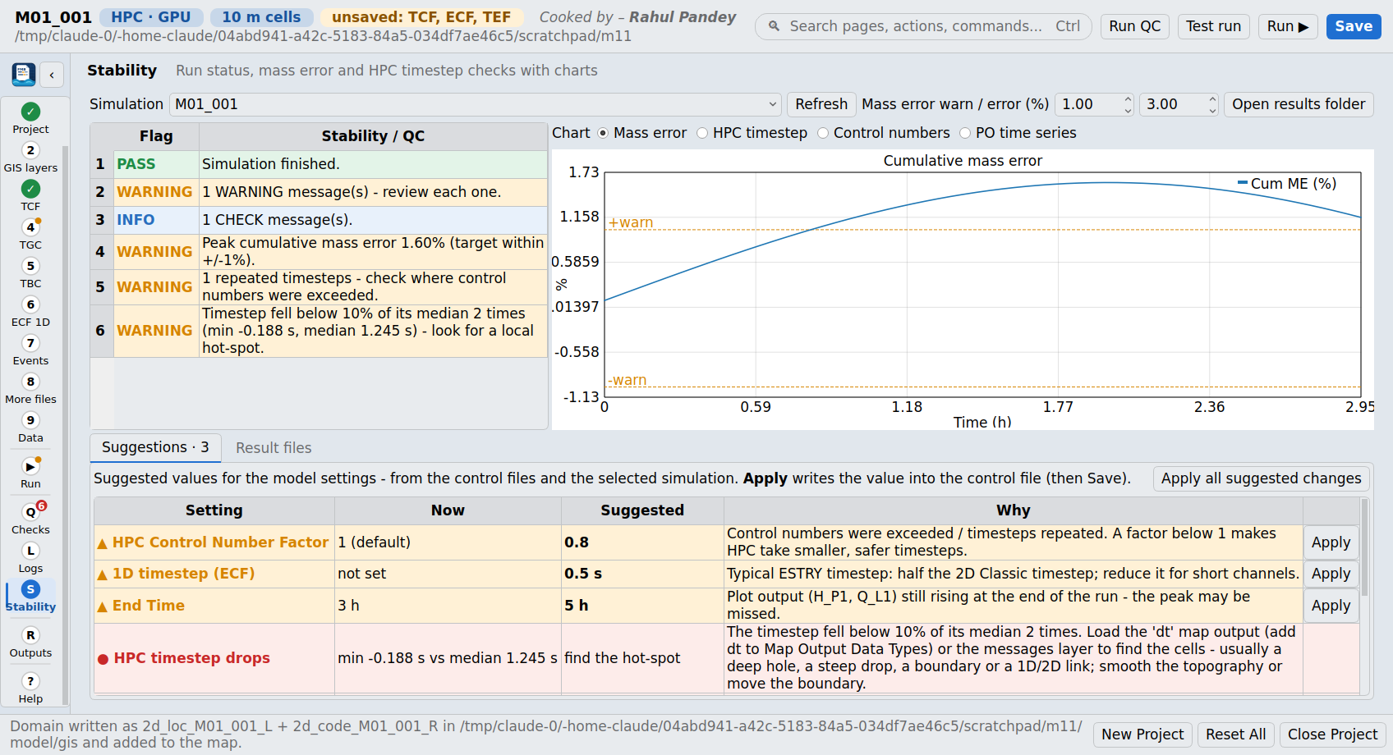
Figure 15 - Cumulative mass error chart with the +/- warning lines

HPC adaptive timestep
TUFLOW HPC chooses its own timestep every step so that the control numbers stay below their limits. A smooth timestep that follows the flood is healthy. Sudden drops (the plugin flags drops below 10 % of the median) point to a 'hot-spot': a few cells with deep or fast water - a hole in the DEM, a steep drop, a boundary, a 1D/2D link. Add 'dt' to Map Output Data Types to map where the minimum timestep happens. A repeated timestep means a step broke a limit and was redone with a smaller step.

Control numbers Nu, Nc and Nd
Number | What it measures | Limit used
Nu (Courant) | How far water moves in one step compared with the cell size: Nu = |V| dt / dx. | 1.0
Nc (celerity) | How far a shallow-water wave travels in one step: Nc = (sqrt(g d) + |V|) dt / dx. | 1.0
Nd (diffusion) | Stability of the sub-grid turbulence (viscosity) term: Nd = nu_t dt / dx^2. | 0.3
V = velocity, d = depth, g = 9.81 m/s2, dx = cell size, nu_t = eddy viscosity. These are the HPC default limits. The Control Number Factor scales them: below 1 makes HPC take smaller, safer timesteps; above 1 'overclocks' it.
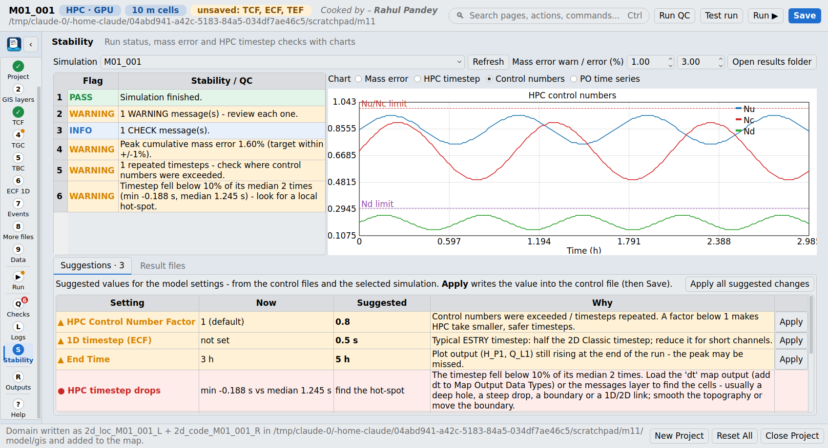
Figure 16 - Control numbers chart with the Nu / Nc and Nd limit lines

Classic timestep
The Classic solver uses a fixed timestep. TUFLOW's guidance is a timestep in seconds of about 1/4 to 1/2 of the cell size in metres (e.g. 2.5 - 5 s for 10 m cells). Too large a step gives instability, negative depths and mass error; too small just runs slowly.

1D (ESTRY) timestep
ESTRY is explicit, so its timestep must let a wave cross the shortest channel in more than one step: dt < L / (sqrt(g d) + V). The plugin assumes d = 5 m and V = 2 m/s, which gives roughly dt < L / 9 (L in m, dt in s). Very short channels force very small timesteps - lengthen or merge them where possible.

Wet/dry depth
Cells shallower than the wet/dry depth are treated as dry. The HPC default is 0.002 m. For direct rainfall the manual recommends 0.0002 m, otherwise thin sheet flow is held back and mass is lost.

Cell size, cell count and SGS
Run time grows quickly with resolution: halving the cell size gives 4x the cells and about half the timestep, so roughly 8x the run time. Aim for at least 4 - 5 cells across the main flow paths. The plugin warns about grids above about 30 million cells on GPU, 8 million on HPC CPU and 2 million on Classic; the free demo mode is limited to 100,000 cells. Sub-grid sampling (SGS) samples the DEM inside each cell so narrow channels and banks keep their storage and conveyance - often allowing a coarser, faster grid.

6.3 Suggestions
The Suggestions tab gives a value for every key setting, always - either a change (amber, with Apply), the current value confirmed (green), something to look into (red) or a note (blue). Apply writes the value into the control file (save afterwards); Apply all suggested changes applies every change. Double-click a row to open its manual page. Before any run, the suggestions come from the control files only.
Setting | Rule | Suggested value
2D timestep (Classic) | Unstable, negative depths or mass error above the warning limit | The smaller of half the current timestep and 1/5 of the cell size
2D timestep (Classic) | Not set, or more than 1/2 of the cell size | 1/4 of the cell size
2D timestep (Classic) | Below 1/5 of the cell size and the run was clean | 1/4 of the cell size (faster)
2D timestep (Classic) | Otherwise | Keep (range 1/5 - 1/2 of the cell size)
2D timestep (HPC start) | Not set | 1/4 of the cell size; otherwise keep (adaptive). Linked to Flood Modeller: set in the .ief
HPC Control Number Factor | Unstable, control numbers exceeded, repeated timesteps, or high mass error | 0.8 (or 0.1 lower than the current value, not below 0.5)
HPC timestep drops | Timestep fell below 10 % of the median | Find the hot-spot (dt map output, messages layer)
Cell size | Cell count above the limit for the solver / hardware | Coarser cell rounded to 1, 2, 2.5 or 5 x 10^n, giving about half the limit
Cell size | Otherwise | Keep, with the finer option (half) and its cost
Sub-grid sampling (SGS) | HPC, SGS off, cell size >= 2 m | ON
Cell Wet/Dry Depth | Direct rainfall and the depth is not set or > 0.0002 m | 0.0002 m
1D timestep (ECF) | Shortest channel L read from the 1d_nwk layers | dt < L / (sqrt(9.81 x 5) + 2), halved after an unstable run
1D timestep (ECF) | Not set and lengths unknown | Half the 2D timestep (min. 0.5 s)
End Time | A plot-output series peaks in the last 5 % of the run and is still rising, or the 2D volume is still rising | End Time + 25 % (at least + 0.5 h)
Map Output Interval | More than 400 or fewer than 10 map outputs, or not set | Duration / 100 outputs
Time Series Output Interval | Not set or coarser than max(300 s, half the map interval) | 60 s (coarser for very long runs)
Mass error | Above the warning limit | Investigate: early = initial conditions; at boundaries = inflow location / HQ slope; with 1D = links or 1D timestep
Log warnings | Warnings in the log | Review each one (Logs tab / messages layer)
Suggested numbers are rounded to 'nice' values: 1, 2, 2.5 or 5 times a power of ten.
Important: Suggestions are guidance that follows the TUFLOW manual and common practice. They do not replace the modeller's judgement - always re-run and re-check the mass error, the control numbers and the results after a change.

7 Outputs
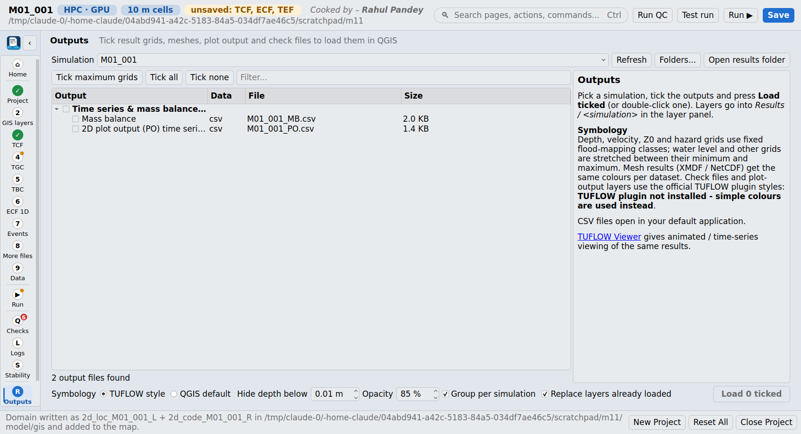
Figure 17 - Outputs page
Lists every output of a simulation in one tick list and loads the ticked ones into the layer group Results / <simulation>.
Category | Contents
Maximum / summary grids | <sim>_<type>_Max grids, time of peak (TMax_), duration and time of inundation.
Time-step grids | <sim>_<type>_<time> grids.
Mesh results | XMDF, NetCDF and DAT results (with the .2dm mesh).
Plot output & 1D results (GIS) | PLOT_P / L / R, 1D maximum water levels / flows / velocities, channel capacity, reporting locations.
Time series & mass balance (CSV) | PO time series, 1D water levels / flows / velocities, mass balance (opened in the default program).
Check files | zpt, grd, bcc, sac, 1d_to_2d, nwk ... from the check folder (each described).
Messages | The messages layer.

7.1 Symbology
With 'TUFLOW style', grids and meshes get fixed flood-mapping classes; check files and plot output use the official TUFLOW plugin's styles when it is installed. Depth classes start at the 'Hide depth below' value (default 0.01 m); opacity can be set.
Result | Classes
Depth d (m) | 0 - 0.15, 0.15 - 0.3, 0.3 - 0.5, 0.5 - 1.0, 1.0 - 2.0, > 2.0 (light to dark blue)
Velocity V (m/s) | 0 - 0.5, 0.5 - 1.0, 1.0 - 1.5, 1.5 - 2.0, 2.0 - 3.0, > 3.0 (yellow to red)
Velocity x depth Z0 (m2/s) | 0 - 0.1, 0.1 - 0.3, 0.3 - 0.6, 0.6 - 1.0, > 1.0 (green to red)
Hazard ZAEM1 | H1 - H6 (Australian Emergency Management hazard categories, 2017)
Water level h, unit flow q, time, elevation, Manning's n, others | Colour ramp stretched between the minimum and maximum

7.2 Map output data types
Code | Meaning | Code | Meaning
h | Water level (m) | Z0 | Velocity x depth (m2/s)
d | Depth (m) | ZUK0 | UK hazard rating (FD2320 / FD2321)
V | Velocity (m/s) | ZAEM1 | Hazard category H1 - H6 (AEM 2017)
q | Unit flow (m2/s) | BSS / SP | Bed shear stress / stream power
n | Manning's n | MB1 / MB2 | Mass error
dt | Minimum timestep (s) - finds hot-spots | CI | Cumulative infiltration (mm)

8 Help
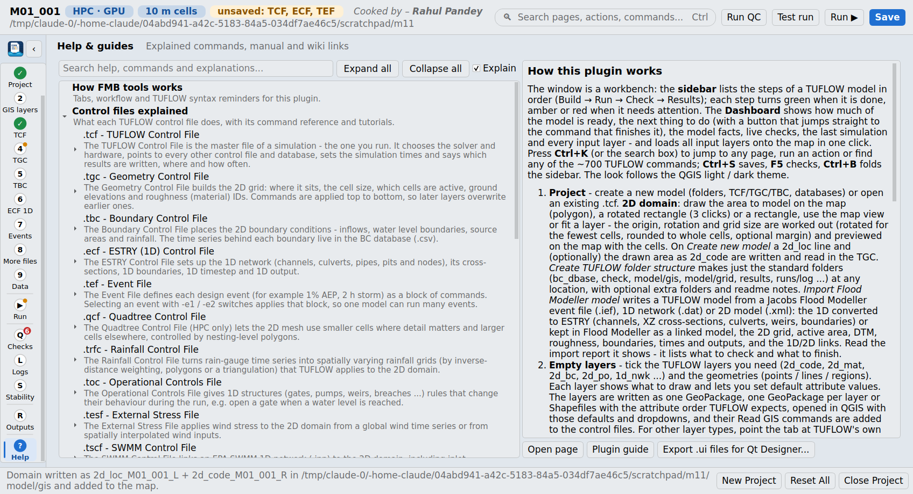
Figure 18 - Help page
The Help page explains how the plugin works, each control file, every Essentials command (syntax, default, tips, manual link) and every manual chapter, appendix, tutorial, message database page, check-file page and tip - each with a short note on what it covers. Everything is searchable by title or explanation; double-click opens the page. Export .ui files for Qt Designer writes the window and every page as Qt Designer files. The Project page itself is loaded from ui/designer/project_tab.ui, so its layout can be edited in Qt Designer (keep the object names the code uses).

9 Thresholds and constants used
Every number the plugin uses to judge a model, where it is used and where it comes from.
Value | Used in | Basis
Classic timestep 1/4 - 1/2 of cell size (QC warns > 0.5, notes < 0.1) | Checks, Suggestions, new-model default | TUFLOW manual guidance for the Classic solver
Cumulative mass error +/-1 % warning | Stability, Suggestions | TUFLOW manual / modelling guidance (user adjustable)
Cumulative mass error 3 % error | Stability | FMB tools default (user adjustable)
First 5 % of the mass-balance record ignored | Stability | FMB tools (start-up noise)
Nu 1.0, Nc 1.0, Nd 0.3 | Stability, Suggestions | TUFLOW HPC default control-number limits
Timestep drop < 10 % of median | Stability, Suggestions | FMB tools heuristic
Control Number Factor 0.8 suggested; > 1 and 0 flagged | Checks, Suggestions | TUFLOW manual (Control Number Factor)
Cell Wet/Dry Depth 0.0002 m for direct rainfall (default 0.002 m) | Checks, Suggestions | TUFLOW manual
Manning's n 0.008 - 1.0 accepted (usual 0.01 - 0.5) | Checks | Typical published Manning's n ranges
100,000 cells | Checks | TUFLOW free / demo mode limit
5 M / 20 M cells (domain summary), 2 M / 8 M / 30 M cells (Classic / HPC CPU / HPC GPU) | Project, Suggestions | FMB tools practical run-time guidance
Map Output Interval: warn if longer than the run; note if < 30 s; suggest ~100 outputs | Checks, Suggestions | FMB tools practical guidance
1D timestep dt < L / (sqrt(g x 5 m) + 2 m/s) | Suggestions | Courant condition of the explicit ESTRY scheme
End Time + 25 % when a peak is still rising in the last 5 % | Suggestions | FMB tools heuristic
Weir / culvert defaults on import: entry 0.5, exit 1.0, height / width contraction 0.6 / 0.9, n 0.015 | Flood Modeller import | Common ESTRY defaults
CN search distance max(3 cells, 100 m); structure node offset 2 m | Flood Modeller import | FMB tools

10 Files written by the plugin
File / folder | Content
runs\<name>.tcf | TUFLOW control file (and the batch file you save).
model\<name>.tgc / .tbc / .ecf / .qcf, event_file.tef | Child control files.
model\gis\<name>.gpkg (or Shapefiles) | GIS layers: 2d_loc, 2d_code, 2d_mat, 2d_bc, 1d_nwk, 1d_xs, 1d_bc ...
model\grid | DEMs (copied by the Flood Modeller import).
model\csv\xs | 1D cross-section tables (X, Z, N).
model\materials.csv | Material ID, Manning's n, ..., comments.
bc_dbase\bc_dbase.csv and bc_dbase\1d, \2d | Boundary database and time series (times in hours).
runs\.fmb_tools.json | Plugin state: batch settings, scenarios and events.
FM_import_report.txt | Flood Modeller import report.
runs\<name>_TUFLOW.ief | Linked Flood Modeller event file (linked import).

11 References
Command names, syntax and defaults come from the command index of the TUFLOW Classic / HPC User Manual 2026.3 (Appendices A - K). Explanations and links always open the official online pages so they stay current.

11.1 TUFLOW manual (2026.3)
- TUFLOW Classic / HPC User Manual (latest) - the authoritative description of every feature
- 3 Hydraulic modelling fundamentals - timestep, control numbers, HPC adaptive timestepping
- 4 Control files and input layers - control-file syntax, GIS inputs, databases
- 5 1D network domains - ESTRY - channel types, cross-sections, culverts, bridges
- 7 2D domains - grid, Zpts, SGS, Quadtree, materials
- 8 Boundaries and initial conditions - boundary types, BC database
- 10 Combining domains and solvers - HX / SX links, Flood Modeller linking
- 11 Outputs - map output formats and data types
- 14 Checks and log files - logs, messages layer, check files
- 16 Quality control and troubleshooting - model review, instabilities

11.2 TUFLOW Wiki
- TUFLOW Modelling Guidance - cell size, boundaries, structures, mass error
- TUFLOW Messages database - every numbered ERROR / WARNING / CHECK
- TUFLOW Check Files - what each check layer shows
- Run TUFLOW from a batch file - batch switches
- Tutorial models (Modules 1 - 11) - the folder structure and layers the plugin follows
- 1D-2D Flood Modeller - TUFLOW - HX / CN / SX links to a Flood Modeller 1D model
- Flood Modeller Tutorial Module 01 - linked model set-up; times read from the .ief
- TUFLOW QGIS Plugin (official) - styles and tools that work alongside FMB tools
- TUFLOW Viewer - time series, profiles and animations

11.3 Other sources
- Flood Modeller (Jacobs) help - DAT / IED / IEF / 2D XML file formats and units
- Flood Modeller Python API documentation - DAT, IEF and XML2D file structures
- floodmodeller-api (Jacobs, open source) - file-layout reference and test data (no code reused)
- Australian Disaster Resilience Handbook 7 - Managing the floodplain (2017) - flood risk management framework
- Australian Disaster Resilience Guideline 7-3 - Flood hazard (2017) - hazard vulnerability categories H1 - H6
- Defra / Environment Agency FD2321 - Flood risks to people, Phase 2 - UK hazard rating HR = d (v + 0.5) + DF
- QGIS API documentation - editor widgets, layers, map tools
- GDAL / OGR - GeoPackage and Shapefile writing

12 Glossary
Term | Meaning
TCF / TGC / TBC / ECF / TEF | TUFLOW control file / geometry / boundary / ESTRY (1D) / event control files.
HPC / Classic | TUFLOW's current GPU-capable solver with adaptive timestep / the original fixed-timestep solver.
ESTRY | TUFLOW's 1D solver for channels, culverts and pipes.
SGS | Sub-grid sampling of the DEM inside each 2D cell.
Quadtree | Mesh with finer cells where nesting polygons ask for them.
2d_loc / 2d_code / 2d_mat / 2d_bc | Grid location line / active-area / materials / boundary layers.
HX / CN / SX | 1D-to-2D water-level link line / connection line to a 1D node / flow link at structure ends.
bc_dbase.csv | Boundary condition database: Name, Source, Column 1, Column 2 ...
CME | Cumulative mass error (%).
Nu, Nc, Nd | HPC control numbers (Courant, celerity, diffusion).
IEF / DAT / IED | Flood Modeller event file / 1D network data file / event data file.

